
8th South West Leeds Scout Group
Annual General Meeting 2020/2012
Online Zoom Meeting - 20 July 2021
AGENDA
- Welcome from the Chair
- Attendees & Apologies
- Nominations & Election for Executive Members
- Minutes of last Annual General Meeting (2020/2021)
- Chair/ Group Scout Leader Joint Report
- Treasurers Report and Approval of Financial Report
- All Sections Report
- Any Other Business
- Close of A.G.M.
NOMINATIONS & ELECTION FOR EXECUTIVE MEMBERS
- Steve Hoggart - Group Scout Leader (to be replaced - temporarily continuing)
- Chair – Gavin Cunningham (to be replaced - temporarily continuing)
- Jeanette Riley – Group Treasurer
- Group Secretary – Lisa Elliott (to be replaced - not continuing)
- Suzanne Burge – Fundraising (TBC)

- Co-opted members: Leaders
The following leaders have expressed an interest in acting as co-opted members on the Executive Committee:
- Carol Houlding (Beaver Leader)
- Tracey Lazenby (Assistant Beaver Leader)
- Steve Riley (Scout Leader)
- Ray Thorne (Cub Leader)

MINUTES
Of the last Annual General Meeting (2020/2021)iIncluding the annual accounts 2019/2020
The minutes shown in Appendix A are offered as a true record of the 2020 A.G.M. covering the events of the year 2019/2020.

CHAIR/ GROUP SCOUT LEADER JOINT REPORT

This years report is rather unusual I’m afraid due to the pandemic and the personal issues Gavin and myself have and continue to have. For expediency apologies but this is a joint report.

Firstly we would like to thank the section leaders for their tremendous efforts in continuing to operate mainly though the zoom meetings over this period, they have done well in achieving so many virtual activities and gaining over three hundred badges. We would also like to thank the group executive in particular our treasurer Jeannette for managing our finances over this difficult period.

Whilst the group are in a relatively strong position we desperately need to bolster our executive committee. There is an urgent need to appoint a secretary for the group has Lisa is due to step down at the AGM. Thank you to Lisa for her work and tireless efforts over recent years. On the theme of trying to bolster the group we need support across the cub and scout sections if you are interested please see either the section leaders or myself no matter how little time you can spare we know it will help.

Finally we look forward to the group getting back to some sort of normality in this next period it has been so difficult for so many charitable organisations, however I’m so pleased we have managed to remain financially viable thanks to everyone across the scouting organisation.

Your in Scouting

Steve Hoggart
Gavin Cunningham

Group Scout Leader & Chair of the group

FINANCIAL REPORTS
Treasurers Report as at 31 March 2021
8th South West Leeds

- The only cash received during the year was from Ray for Cub activities, this has been spent and £59 cash in hand accounted for.
- Cash remaining in hand from last year is £114 which will be banked as soon as possible as this is now all coinage. For the start of 21/22 season £745 has been allocated to Steve for tents and equipment, £100 to Carol for Beavers equipment and £235 to Ray for Cubs equipment.
- With costs for insurance and levy still being met from our reserves these have reduced by £800 from £8,197 to £7,397.
- This is after allocating £300 towards the scout award received in October 2020. Exec to agree what this event is and when as we have to report on this and should keep something to show the scout association.
- With no use of the church we did not incur rent of £750.
- Rent for 21/22 is expected to be £40 per week. Exec to clarify how many weeks in 21/22 will be booked. Estimate 30 weeks would amount to £1,200. To be paid weekly from cash subs received by cubs.
- We received a discount on levy for 20/21 of over £2,000, this cannot be relied on for 21/22, so already our costs will be over £4,000 plus Beaver costs. (£1,200+£2700+£300insurance)
- Exec to agree what can be achieved by increasing subs and how we will increase fund raising.
- The Annual Statement and associated books will be approved in due course.

Provided by Jeanette Riley, Group Treasurer

8th South West Leeds Scout Group
Receipts and Payments Account

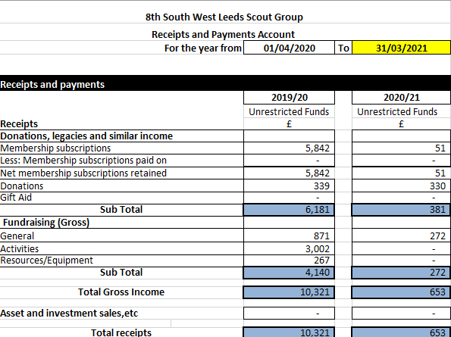
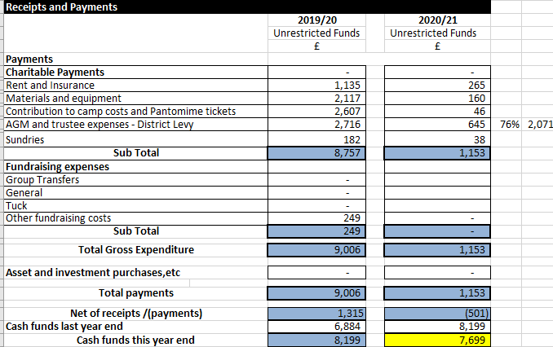

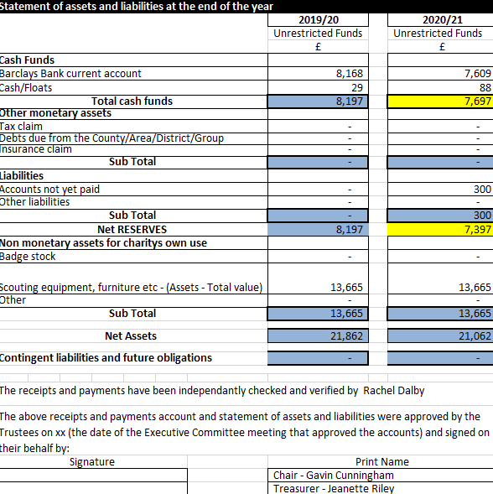

8th South West Leeds Group Annual Report April 2020 - March 2021
ALL SECTIONS REPORT

Despite a year of Lockdown and restrictions the Group across all Sections have managed to earn over 300 badges.
We have had challenges on Facebook from Where’s Akelas Necker? Video, visits to the Zoo, Camp At Home events and County and District events over Facebook and YouTube.
We have also had the Badges At Home on OSM active, with plenty of excellent badge work being submitted.
Mainly I have been running weekly Zoom meetings for all three Sections, where we have covered a wide range of things, from the Great Indoors Badge, Escape rooms ranging from Harry Potter to Escape the Brownies; Cooking Pizza In A Mug, Cake In A Mug and Armpit Fudge.
We have had visits from Hearing Dogs and a local Councillor.
We covered a wide range of Badges including Book Reader to Navigator. Had fun crafting and lots of Quizzes (Although my carefully crafted Mr Men’s Quiz was destroyed by one very clever Beaver).
Well done to all who kept Scouting during this difficult year and well done to the three Cubs who still managed to complete their Chief Scout Silver Awards.
Looking forward to a more normal Scouting year.
Ray Thorne
CSL

APPENDIX A – MINUTES FROM THE 2019/2020 AGM
