
8th South West Leeds Scout Group
Annual General Meeting 2019/2020
Online Zoom Meeting 14th January 7pm
AGENDA
- Welcome from the Chair & Chair’s report
- Apologies
- Nominations & election for Executive members
- Co-opted members: leaders
The following leaders have expressed an interest in acting as co-opted members on the Executive Committee:
- Carol Houlding (Beaver Leader)
- Tracey Lazenby (Assistant Beaver Leader)
- Steve Riley (Scout Leader)
- Ray Thorne (Cub Leader)
- Christine Dixon (Occasional Helper)
- Minutes of last Annual General Meeting (2019/2020)
- Chair’s report
- Financial Reports
  - Treasurers Report and approval of Financial Report
  - West Leeds Scout District Council – Coronavirus Finances
- Section reports;
  - Group Scout Leader Report
  - Group Scout Report
  - Group Cub Report
  - Group Beaver Report
- Any other business
- Q & A
- Close of A.G.M.
MINUTES
(of previous A.G.M. including the annual accounts)
The minutes shown in appendix A are offered as a true record of the 2019 A.G.M. covering the events of the year 2018/2019.
Please refer to appendices A at the back of this document.

CHAIRS REPORT

April 2019-March 2020 has been another busy year for the group, and again I would like to begin by thanking all the group leaders, assistants, executive committee members and helpers for their hard work.

Numbers have increased in all sections thanks to the efforts of all the Leaders who have maintained a varied, interesting and most importantly fun programme of activities throughout the period.

We must also thank the parents too for being prepared to bring and collect their children and wait outside in all weathers on a Wednesday evening, without their efforts we would have few children to fill the halls.

The Facebook has continued to be a primary source of information and demonstration of group’s capabilities and is something to be proud of, with Judith and Ray for keeping the page up to date throughout the year.

The group has participated in some successful regional & district activities as well as our own 8th SWL activities and camps.

The Group Executive Committee has maintained numbers this year but will always benefit from additional members with new ideas on how to progress the groups fundraising efforts. If any parents would like to become involved in this important aspect of Scouting then please feel free to approach any of the executive committee or Section leaders for details of how to become involved.

The fundraising aspect of the executive committee may be ever more important in the upcoming 2020-2021 year due to the ravages of the COVID pandemic and the effects and disruption it has caused in all aspects of daily life.

Last year the group took the decision to increase the subscriptions to cover costs and help build up contingency funds that could also be spent on group activities in the event of surplus above the agreed levels. As you will see from the treasurers reports the strategy of a raise to £2.50 and reduction in expenditure has helped the financial situation improve despite a downturn in overall income.

Despite the strong looking financial situation to the financial year end we must be very careful of the position we find ourselves in, as the ravages of the COVID pandemic are only just beginning to be felt and a national Lockdown began at the end of March. With no end date to restrictions planned and a ban on face to face meetings for the immediate future income could be severely affected in the next financial year 2020-2021.

The Scouting fraternity throughout the country has been split on the subject of weekly subscriptions when no face to face meetings are taking place. Some have asked parents to volunteer to pay whilst others like ours have not formally made this request. This should be a welcome decision for many families who have been placed on reduced income/furlough or even become unemployed.

Hopefully the group’s reserves will stand us in good stead and allow our group to continue its success once the Pandemic eases and some normality returns.

On a more positive note the Group will be making every effort throughout the restrictions to continue to provide the local scouting experience and group involvement. This will take the form of on line meetings via the Zoom facility that the Scout Association is currently negotiating. There will also be opportunity to participate in on line badge achievement with activity and evidence reporting provision on line, and even the possibility of virtual on line camping events.

Finally I would like to announce some changes to the group leadership that are already in motion and will shortly take effect.

Our Group Scout Leader Steve Hoggart stood is proposing to stand down, allowing him chance to pursue more activities unrestricted in his new found retirement. Steve started out in the Beaver Colony for the 8th SWL group and since taking on the GSL role 20 years ago has been a major contributor to its success behind the scenes running the technical and legal aspects of Scouting on behalf of our group. Steve has been a Uniformed Leader for 28 years, but will continue his association with the group as an occasional helper.

Also In the coming months Joan Kirkby Assistant Group Scout Leader is standing down, and has also taken the decision to retire from Scouting at the end of September. After 43 years in Scouting Joan is a familiar face to all groups and has most recently participated as a supporting Section Leader in Cubs. As AGSL Joan’s main role has been running the administration and paperwork aspects of the Group and has been the right hand assistant to Steve.

Together Steve and Joan have been helping to keep the group running smoothly and liaising with the District and County levels of scouting management to ensure the continued successful operation of 8th SWL.

I am sure you will all join me in thanking Steve and Joan for all their years of dedication to the group and wishing them happiness and success in their new chapters of life.

The upcoming year in scouting could well be the most difficult and challenging for a generation but by working together and showing resilience we will be able to keep our group the successful and enjoyable organisation it has become.

Yours in Scouting
Gavin Cunningham
Chair 8th SW Leeds

FINANCIAL REPORTS
Treasurers Report as at 31 March 2020

- All receipts and section sheets have been received. Cash collected has not been banked yet as the banks opening hours and queues have made this impossible, however the cash will be taken to the post office in complete bags to be banked. This means there will be some cash in hand to bank as soon as possible.
- We have not received the Cornwell Memorial Grant of £300 for Chloe’s Medal of Meritorious Conduct award. The grants department have been on furlough until recently and are looking at payments of outstanding grants as soon as possible. As this was to contribute towards some close contact activities members to agree what if any changes to the plan.
- We have £8,197 free reserves assuming that we have sufficient evidence to support the wades grant received in March 2018.
- We can access match funding from Halifax and have received £315 this year.
- Rent of £750 is normally due from 1 April 2020. With nil funds coming in this may be a liability cost.
- The Annual Statement and associated books will be approved week commencing 17 August 2020. These need to be approved before they can be sent to district.

West Leeds District have asked for a statement of our financial position to support a potential reduction in the annual capitation fee.

We have responded with following:
Our current premises are currently under review as they are due to be sold, this means we need to keep aside some reserves in order to fund potential resettlement costs. The capitation costs represents over 30% of our current cash reserves and with Nil income forecast for the foreseeable future this will reduce our reserves to less than £5,500 which our exec members feel is untenable and with the prospect of any significant fundraising being difficult this will place our group at risk of closure. Therefore, a significant reduction/deferral of this year’s capitation fee would be more than welcome.

8th South West Leeds Scout Group
Receipts & Payments Account 2019-2020

8th South West Leeds Beavers

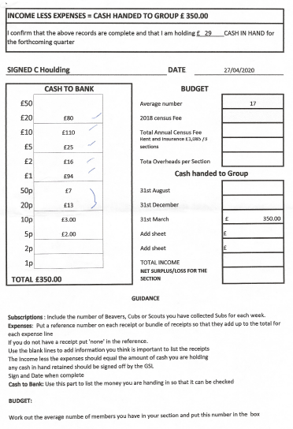

8th South West Leeds Cubs

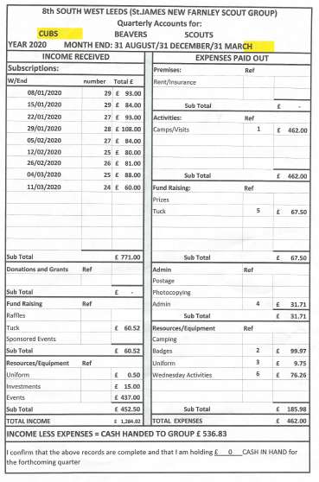

8th South West Leeds Scouts

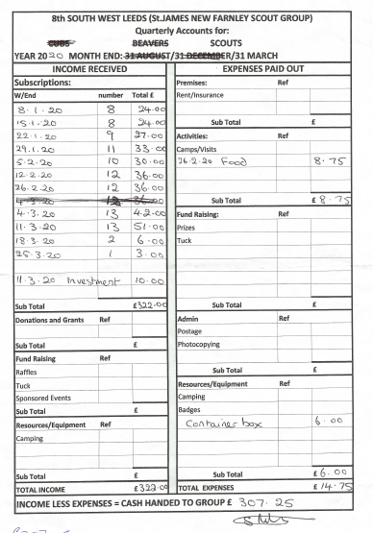

West Leeds Scout District Council – Coronavirus Finances

Coronavirus has had an enormous effect on all aspects of our lives, and this applies to Scouting as well. The District Executive is well aware of this and in particular on the financial effect on the Groups in its area. The Exec held its first meeting virtually since the lockdown began last Monday, and after a prolonged discussion agreed to commit itself to paying a significant amount of Groups capitation charge which will be due in March 2021, as for most if not all Groups this is the biggest cost they incur in a year.

To help us arrive at a decision as to the exact level of support we will give, we are asking all Groups if they could update us on their financial position at the moment. This information should include the current amount of cash and bank balances ( both current accounts and any deposit accounts etc. ), together with the level of monthly income under the current circumstances ( which may well be £NIL) and the amount of monthly expenditure being currently incurred. We would also ask if you could supply us with details of your average monthly income figure and average monthly expenditure figure ignoring the capitation charge once Scouting returns to normal plus any unusual large payments you have coming up . Please feel free to supply any further information or make any comments you think would help us. We are asking if all Groups could supply us with this information by 31st August 2020.

Scout HQ have indicated they are looking to bring the annual Census date forward to 15th October each year starting this year to allow more time for the figures to be analysed to arrive at the annual Capitation charge, although the payment date will remain the same at 31st March.

Our AGM which was due on 22nd July 2020 has been put back to 21st October 2020, which will give us time to look at the above information and also have census figures available to enable us to arrive at a decision re the help to be given to Groups re the capitation charge, as we are expecting this to be at the forefront of people’s minds when attending the meeting. It also might be by that time that a face to face meeting will be able to be held.

Please remember that financial accounts for the Groups still need to be produced, and that AGM meetings are also required. These can be held virtually, which will need recording clearly on the minutes.

Yours in Scouting

Peter Bainbridge
West Leeds Scout District Treasurer

8th South West Leeds Group Annual Report April 2019 - March 2020
GSL & AGSL REPORT

The group numbers over the last few years have remained fairly constant. However the total number of leaders and young people as at the January 2019 census stood at 85 this has increased by 12 in total since January 2018.
The breakdown of this:
- Beavers 22
- Cubs 30
- Scouts 14
- Section Leaders 8
- Sectional Assistants 4
- Group Scout Leaders 2
- Group Exec Members 5
Leader Training:
All leaders have completed their reviews and training where required in this last year.
The main area of training covered in the last year was: 1st Response (First Aid) and safeguarding.
Leaders Meetings & Events:
- We have held numerous meetings as leaders including the attendance at district and at regional level. Group executive meetings have been attended by co-opted section leaders.
- Another busy year as the section leaders implemented their balanced programmes.
- The West Leeds District held a social for Leaders and Exec Members in October which brought about a very pleasant evening for all who attended.
- The group supported the New Farnley Vision Group with Display’s, games etc. This was well supported by the community and celebrated the 10th anniversary of the group
Executive Meetings:
- Regular meetings have taken place. The Wade’s charity application for a grant towards lighting, tables and chairs for camps was successful, with a contribution of £750. We are in the process of purchasing the equipment in accordance with the application.
- There are still important roles within the group to be filled. If anyone is interested in becoming more involved they can contact the executive members, section leaders or myself for more information.
- Given the implications of Covid 19 (March) and how this will impact on scouting and our personal lives, time will tell!!
- Finally we would like to express our thanks and appreciation to all the leaders, assistants, parents and of course you the parents / guardians for coming along each week.

Steve Hoggart (Group Scout Leader)
Joan Kirby (Assistant Group Scout Leader)
8th South West Leeds Group Annual Report April 2019 - March 2020
SCOUT REPORT

Meeting Place: St James Church.
Wednesday evenings, school term-time: 8.00 – 9.30 p.m.

We currently have 2 leaders and 16 Scouts.

Programme April 2019 – March 2020
- Local Litter Pick with Beavers & Cubs
- Scouts attended St Georges Day parade.
- Expedition Challenge Weekend
- Climbing
- Swimming
- Hikes
- Summers Day
- Bramley War Graves
- Games Night in Farnley Park with Cubs
- Group Camp
- Remembrance Parade
- Scouts Christmas Camp
- Camp At Home

Scout Section has been busy throughout the year earning many badges like Creative, Expedition, Entertainer, Fundraising, Model Maker, Navigator and Photographer

We also had one Chief Scout Gold Award, which is the Scouts highest achievable badge.

Sadly, due to bad weather this year we have had very few camps.

Thank you to all the leaders, helpers, and parents for their continued support over the past year.

Steve Riley, Scout Leader

8th South West Leeds Group Annual Report April 2019 - March 2020
CUB SCOUT REPORT

Meeting Place: St James Church.

Wednesday Evenings School Term Time: 6.15 to 7.45pm

We currently have 24 Cubs in the section.

Programme April 2019 – March 2020
- Local Litter Pick with Beavers & Scouts
- Cubs attended St Georges Day parade.
- Cubadoodledoo Camp
- District Archery
- County Trading Post
- 5 A-side Football
- Summers Day
- Bramley War Graves
- Games night in Farnley Park with Scouts
- Canal Boat Trip
- Group Camp
- Water Activity Day
- Remembrance Parade
- County Panto
- Clip ‘n’ Climb
- Cub Quiz Night
- District Archery
- Camp At Home

Cub Section has been busy throughout the year earning many badges like Naturalist, Sports Enthusiast, Personal Safety, Musician, Pioneer, Physical Recreation, Time On The Water, Digital Citizen and Scientist with the help of Amy Crow.

We also had three Chief Scout Silver Awards, which is the Cubs highest achievable badge.

Although we had the big Cubadoodledoo Camp and group camp, sadly with a year of bad weather and then the Country lockdown we have had no other camps this year.

Thank you to Jack (Assistant Cub Scout Leader), Judith (OH and badge record-keeper), Charlotte and Chloe our young leaders.

Ray Thorne
Cub Scout Leader

8th South West Leeds Group Annual Report April 2019-March 2020
BEAVER SCOUT REPORT
We currently have 19 Beavers in the Colony and 2 on the waiting list. 6 Beavers went up to Cubs by the end of Oct 2019.
Meeting Place: New Farnley Community Centre
Wednesday Evenings School Term Time: 6:00 to 7:30pm
Programme: April 2019 – March 2020
Events & Activities throughout the year
- St Georges Day Parade
- Remembrance Day Parade to cenotaph on Lawns Lane.
- Christmas Party
- Chinese New Year
- Mother’s Day
- Father’s Day
- Group Camp 4th-6th Oct 2019 at Phoenix Scout Camp
Upcoming Events for 2020-2021
- Challenge 20 Camp at Bramham Park 10th July 2020 was cancelled due to Pandemic Outbreak. Will be done virtually on the 8th & 9th August 2020
Joining Cubs. During the months from Nov 19 to Oct 20 their will have been 8 Beavers that have moved on to Cubs.
Due to the pandemic from March onwards we have not had any meetings. but a small number of Beavers have been joining in on the virtual meetings with Ray. Hopefully we will be back to Face to face meetings in the not too distant future.
Thank You to all the Leaders who give their time and commitment to scouting to ensure that all Beavers enjoy their time with us.
Yours in Scouting
Carol Houlding
BSL

